TRAFFIC MANAGEMENT

PHASE 5: PROJECT DOCUMENTATION AND SUBMISSION

**INTRODUCTION:**

Traffic management coordinates road systems via technology, infrastructure, and policies to optimize traffic flow, enhance safety, and reduce congestion. Utilizing traffic signals, signage, and innovative systems, it aims for efficient, safe, and sustainable transportation networks, integrating urban planning for smoother mobility and improved overall transportation quality The primary objectives of Traffic management include:

1. **Safety:** Enhancing safety for all road users is paramount. Measures such as traffic signals, speed limits, pedestrian crossings, and dedicated lanes for cyclists contribute to reducing accidents and creating a safer environment.
2. **Efficiency:** Managing traffic flow efficiently by minimizing congestion is a key objective. This involves implementing strategies like intelligent transportation systems (ITS), synchronized traffic signals, and lane management to ensure smoother movement of vehicles.
3. **Congestion Reduction:** Alleviating traffic congestion is crucial. Through traffic engineering, better road designs, and effective signaling, traffic jams can be minimized, leading to reduced travel times and fuel consumption.
4. **Optimizing Road Capacity:** Making the most of existing road infrastructure is a significant aim. Maximizing road capacity via measures like lane markings, efficient traffic signal timing, and effective road planning helps to accommodate traffic volumes.
5. **Public Transportation Improvement:** Enhancing public transportation systems encourages reduced reliance on individual vehicles. Priority lanes, improved schedules, and integration with traffic management contribute to an efficient and attractive public transit system.
6. **Technological Integration:** Leveraging technology, such as real-time traffic monitoring and adaptive traffic control systems, is crucial. Smart systems can adapt to changing traffic conditions and aid in better traffic flow management.
7. **Urban Mobility and Sustainability:** Traffic management is intertwined with urban planning. It aims to design cities with well-connected roads, pedestrian-friendly zones, and efficient public transport to create a sustainable and smoothly functioning urban environment

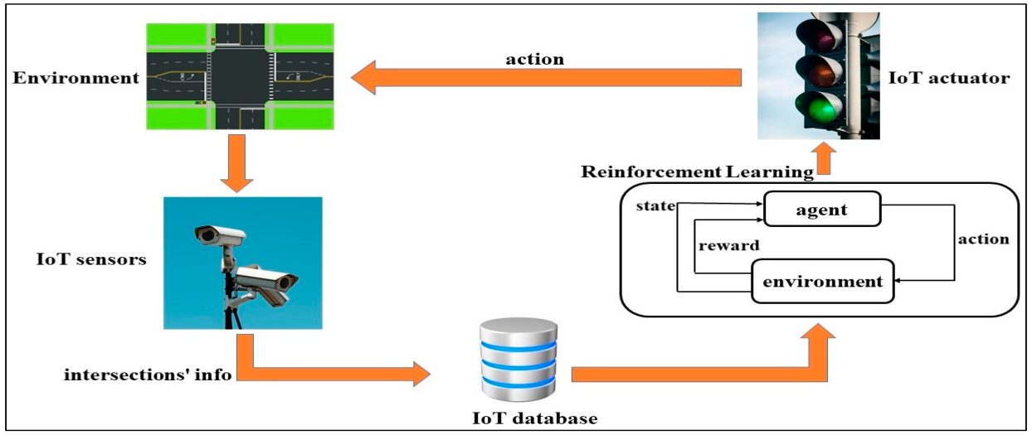

**PROJECT OBJECTIVES:**

1. **Traffic Flow Optimization:** Improving traffic flow efficiency by reducing congestion, utilizing intelligent transportation systems (ITS), and implementing strategies to minimize bottlenecks.
2. **Safety Enhancement:** Prioritizing safety for all road users through measures such as better road design, traffic signals, pedestrian crossings, and initiatives that reduce the likelihood of accidents.
3. **Reduced Environmental Impact:** Minimizing carbon emissions and environmental impact through traffic flow improvements, reduced congestion, and encouraging the use of public transportation.
4. **Technology Integration:** Integrating innovative technologies for real-time traffic monitoring, adaptive traffic control systems, and data-driven decision-making to improve traffic management.
5. **Public Transportation Enhancement:** Promoting and improving public transit systems to reduce reliance on individual vehicles, reducing congestion and environmental impact.
6. **Infrastructure Development:** Implementing or upgrading road infrastructure, such as road layouts, signage, lane management, and smart traffic signal systems.
7. **Community Engagement and Education:** Involving the community in understanding traffic management strategies, educating drivers and pedestrians, and promoting responsible and safe road behavior.
8. **Economic Efficiency:** Boosting economic efficiency by reducing time wasted in traffic, minimizing fuel consumption, and optimizing road infrastructure usage.

**IOT DEVICES:**

###### Internet of Things (IoT) devices play a crucial role in modern traffic management systems, offering real-time data collection and analysis to improve efficiency, safety, and overall traffic flow. Several IoT devices are used in traffic management:

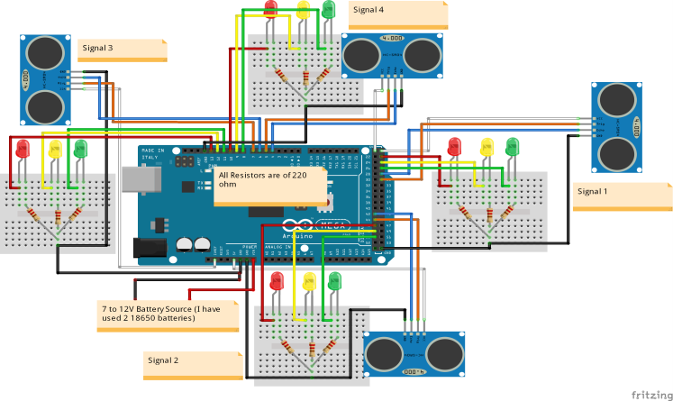

1. **Traffic Sensors:** These devices monitor traffic flow, vehicle speed, and density. Inductive loop sensors, radar sensors, or cameras equipped with computer vision are examples. They collect real-time data on traffic patterns, enabling authorities to make informed decisions for traffic management.
2. **Smart Traffic Lights:** IoT-enabled traffic signals use real-time data to optimize signal timings based on traffic conditions. They adjust signal phases to reduce congestion and improve traffic flow.
3. **Variable Message Signs (VMS):** These signs display real-time traffic information to drivers, providing updates on traffic conditions, accidents, or alternative routes, enabling informed decision-making.
4. **Connected Vehicles:** IoT-equipped vehicles can communicate with each other and with traffic infrastructure, sharing data on speed, location, and potential hazards. This technology can assist in collision avoidance and traffic flow optimization.
5. **Parking Sensors:** IoT sensors in parking spaces relay data about availability, assisting drivers in finding open parking spots, thus reducing congestion caused by drivers searching for parking..
6. **Surveillance Cameras:** Cameras with IoT capabilities can analyze traffic patterns, detect incidents, and aid in traffic management and law enforcement.
7. **Roadway Information Systems:** IoT devices on roads collect data on road conditions, maintenance needs, and structural integrity, allowing authorities to schedule repairs or improvements effectively
8. **Queue Management:** Ultrasonic sensors can be used to monitor queues at toll booths, entry/exit points of parking areas, or drive-through lanes, facilitating efficient management of vehicle queues.
9. **Vehicle Detection on Highways:** Placing ultrasonic sensors on highways allows for monitoring traffic speed, volume, and congestion. This data helps transportation authorities in managing traffic flow, implementing variable speed limits, and providing real-time traffic updates to drivers.

**DEVICE SETUP:**

1. Hardware Requirements:

* Ultrasonic sensors: These sensors are used to detect the presence of vehicles or objects.
* Microcontroller or single-board computer: Devices like Arduino, Raspberry Pi, or specialized IoT boards are used to process sensor data.
* Connectivity modules: Wi-Fi, Bluetooth, or cellular modules enable the transmission of data.
* Power source: Battery or electrical power source for the devices.
* Housing and weatherproofing for outdoor installations.

1. Sensor Placement:

* Determine strategic locations for sensor placement, such as at intersections, parking lots, or along highways.
* Mount the ultrasonic sensors at an appropriate height and angle to accurately detect vehicles.

1. Data Processing and Communication:

* Program the microcontroller or single-board computer to process data received from ultrasonic sensors.
* Establish communication protocols to transmit sensor data to a central server or cloud platform using Wi-Fi, Bluetooth, or cellular networks.
* Ensure data is transmitted securely and reliably.

1. Cloud-Based Data Management:

* Set up a cloud platform or server to receive and process the data transmitted by the IoT devices.
* Develop or use existing software to analyze and manage the received data.
* Implement data visualization tools to present the traffic data in a user-friendly format.

1. System Integration and User Interface:

* Integrate the traffic management system with traffic signals, digital signage, or mobile applications to provide real-time information to drivers.
* Develop a user interface or dashboard for administrators to monitor and manage the traffic data.

1. Testing and Calibration:

* Test the system in real-world scenarios to ensure accurate vehicle detection and data transmission.
* Calibrate the sensors and adjust settings as needed to improve accuracy.

1. Maintenance and Upkeep:

* Regularly maintain the hardware and software components to ensure the system functions properly.
* Update the system with new features and security patches as needed.

**PLATFORM DEVELOPMENT:**

1. **Planning and Design:**

* Define the platform's objectives, target audience, and key features.
* Determine the infrastructure, such as cloud-based or on-premises servers, and select the necessary technologies and frameworks for development.

1. **Architecture Design:**

* Create a comprehensive architectural plan considering components, data flow, scalability, and security.
* Design the database structure and the communication protocols between devices and the platform.

1. **Software Development:**

* Develop the backend system that processes incoming data from IoT devices, analyzes traffic patterns, and manages the platform's functionalities.
* Create APIs to enable communication between the platform and IoT devices.
* Develop a user-friendly frontend interface for users, administrators, or traffic operators to access and manage the system.

1. **Integration of Ultrasonic Sensors and IoT Devices:**

* Integrate ultrasonic sensors with the platform, ensuring they communicate data effectively.
* Implement protocols for device management, data transmission, and error handling.

1. **Real-time Data Processing and Visualization:**

* Implement algorithms for real-time data processing to interpret and analyze traffic information.
* Develop visualizations, such as graphs, maps, or dashboards, to display traffic flow, congestion, and other relevant data.

1. **Security Implementation:**

* Integrate security measures to protect the platform from cyber threats and ensure data privacy.
* Implement user authentication, encryption, and secure data transmission protocols.

1. **Testing and Quality Assurance:**

* Conduct rigorous testing to identify and resolve system bugs, performance issues, and ensure data accuracy.
* Perform stress testing and simulation of real-world scenarios to evaluate the platform's response.

1. **Deployment and Maintenance:**

* Deploy the platform in the intended environment, whether on the cloud or on-premises.
* Provide regular maintenance, updates, and support to ensure the platform's smooth operation and adaptability to changing requirements.

Developing a platform for traffic management involving IoT and ultrasonic sensors requires a multi-disciplinary approach, encompassing software development, hardware integration, data analysis, and user interface design to create an effective and reliable system.

The Arduino code for density based traffic light controller using Arduino is as follows

#include<TimerOne.h>  
int signal1[] = {23, 25, 27};  
int signal2[] = {46, 48, 50};  
int signal3[] = {13, 12, 11};  
int signal4[] = {10, 9, 8};  
int redDelay = 5000;  
int yellowDelay = 2000;  
volatile int triggerpin1 = 31;   
volatile int echopin1 = 29;   
volatile int triggerpin2 = 44;   
volatile int echopin2 = 42;   
volatile int triggerpin3 = 7;   
volatile int echopin3 = 6;   
volatile int triggerpin4 = 5;   
volatile int echopin4 = 4;   
volatile long time; // Variable for storing the time traveled  
volatile int S1, S2, S3, S4; // Variables for storing the distance covered  
int t = 5; // distance under which it will look for vehicles.  
void setup(){  
 Serial.begin(115200);  
 Timer1.initialize(100000); //Begin using the timer. This function must be called first. "microseconds" is the period of time the timer takes.  
 Timer1.attachInterrupt(softInterr); //Run a function each time the timer period finishes.  
 // Declaring LED pins as output  
 for(int i=0; i<3; i++){  
 pinMode(signal1[i], OUTPUT);  
 pinMode(signal2[i], OUTPUT);  
 pinMode(signal3[i], OUTPUT);  
 pinMode(signal4[i], OUTPUT);  
 }  
 // Declaring ultrasonic sensor pins as output  
 pinMode(triggerpin1, OUTPUT);   
 pinMode(echopin1, INPUT);   
 pinMode(triggerpin2, OUTPUT);   
 pinMode(echopin2, INPUT);  
 pinMode(triggerpin3, OUTPUT);   
 pinMode(echopin3, INPUT);  
 pinMode(triggerpin4, OUTPUT);   
 pinMode(echopin4, INPUT);   
}  
void loop()  
{  
 // If there are vehicles at signal 1  
 if(S1<t)  
 {  
 signal1Function();  
 }  
 // If there are vehicles at signal 2  
 if(S2<t)  
 {  
 signal2Function();  
 }  
 // If there are vehicles at signal 3  
 if(S3<t)  
 {  
 signal3Function();  
 }  
 // If there are vehicles at signal 4  
 if(S4<t)  
 {  
 signal4Function();  
 }  
}  
// This is interrupt function and it will run each time the timer period finishes. The timer period is set at 100 milli seconds.  
void softInterr()  
{  
 // Reading from first ultrasonic sensor  
 digitalWrite(triggerpin1, LOW);   
 delayMicroseconds(2);  
 digitalWrite(triggerpin1, HIGH);   
 delayMicroseconds(10);  
 digitalWrite(triggerpin1, LOW);  
 time = pulseIn(echopin1, HIGH);   
 S1= time*0.034/2;  
 // Reading from second ultrasonic sensor  
 digitalWrite(triggerpin2, LOW);   
 delayMicroseconds(2);  
 digitalWrite(triggerpin2, HIGH);   
 delayMicroseconds(10);  
 digitalWrite(triggerpin2, LOW);  
 time = pulseIn(echopin2, HIGH);   
 S2= time*0.034/2;  
 // Reading from third ultrasonic sensor  
 digitalWrite(triggerpin3, LOW);   
 delayMicroseconds(2);  
 digitalWrite(triggerpin3, HIGH);   
 delayMicroseconds(10);  
 digitalWrite(triggerpin3, LOW);  
 time = pulseIn(echopin3, HIGH);   
 S3= time*0.034/2;  
 // Reading from fourth ultrasonic sensor  
 digitalWrite(triggerpin4, LOW);   
 delayMicroseconds(2);  
 digitalWrite(triggerpin4, HIGH);   
 delayMicroseconds(10);  
 digitalWrite(triggerpin4, LOW);  
 time = pulseIn(echopin4, HIGH);   
 S4= time*0.034/2;  
 // Print distance values on serial monitor for debugging  
 Serial.print("S1: ");  
 Serial.print(S1);  
 Serial.print(" S2: ");  
 Serial.print(S2);  
 Serial.print(" S3: ");  
 Serial.print(S3);  
 Serial.print(" S4: ");  
 Serial.println(S4);  
}  
void signal1Function()  
{  
 Serial.println("1");  
 low();  
 // Make RED LED LOW and make Green HIGH for 5 seconds  
 digitalWrite(signal1[0], LOW);  
 digitalWrite(signal1[2], HIGH);  
 delay(redDelay);  
 // if there are vehicels at other signals  
 if(S2<t || S3<t || S4<t)  
 {  
 // Make Green LED LOW and make yellow LED HIGH for 2 seconds  
 digitalWrite(signal1[2], LOW);  
 digitalWrite(signal1[1], HIGH);  
 delay(yellowDelay);  
 }  
}  
void signal2Function()  
{  
 Serial.println("2");  
 low();  
 digitalWrite(signal2[0], LOW);  
 digitalWrite(signal2[2], HIGH);  
 delay(redDelay);  
   
 if(S1<t || S3<t || S4<t)  
 {  
 digitalWrite(signal2[2], LOW);  
 digitalWrite(signal2[1], HIGH);  
 delay(yellowDelay);   
 }  
}  
void signal3Function()  
{  
 Serial.println("3");  
 low();  
 digitalWrite(signal3[0], LOW);  
 digitalWrite(signal3[2], HIGH);  
 delay(redDelay);  
 if(S1<t || S2<t || S4<t)  
 {  
 digitalWrite(signal3[2], LOW);  
 digitalWrite(signal3[1], HIGH);  
 delay(yellowDelay);  
 }   
}  
void signal4Function()  
{  
 Serial.println("4");  
 low();  
 digitalWrite(signal4[0], LOW);  
 digitalWrite(signal4[2], HIGH);  
 delay(redDelay);  
 if(S1<t || S2<t || S3<t)  
 {  
 digitalWrite(signal4[2], LOW);  
 digitalWrite(signal4[1], HIGH);  
 delay(yellowDelay);  
 }  
}  
// Function to make all LED's LOW except RED one's.  
void low()  
{  
 for(int i=1; i<3; i++)  
 {  
 digitalWrite(signal1[i], LOW);  
 digitalWrite(signal2[i], LOW);  
 digitalWrite(signal3[i], LOW);  
 digitalWrite(signal4[i], LOW);  
 }  
 for(int i=0; i<1; i++)  
 {  
 digitalWrite(signal1[i], HIGH);  
 digitalWrite(signal2[i], HIGH);  
 digitalWrite(signal3[i], HIGH);  
 digitalWrite(signal4[i], HIGH);  
 }  
}

**PROJECT DETAILS:**

When implementing IoT for ultrasonic sensors in a traffic management system, the adaptation involves integrating IoT capabilities to enhance data collection, transmission, and decision-making. Here's an outline adapted specifically for utilizing IoT with ultrasonic sensors in traffic management:

**1. Project Planning and Definition:**

* **Define IoT Integration:** Establish how IoT will enhance the traffic management system with ultrasonic sensors. Determine the parameters to monitor, such as vehicle presence or traffic density.
* **Budget and Resources:** Allocate resources for IoT-enabled hardware, communication modules, and cloud services.
* **Project Timeline:** Set milestones and deadlines for IoT sensor integration and testing.

**2. Site Selection:**

* Identify key locations for sensor deployment considering IoT network coverage and relevance to traffic management.

**3. IoT Hardware and Sensors:**

* Select IoT-enabled devices compatible with ultrasonic sensors, with connectivity features such as Wi-Fi, LoRa, or NB-IoT.

**4. Sensor Calibration and Installation:**

* Calibrate and install IoT-integrated ultrasonic sensors at strategic points for accurate traffic data collection.

**5. Data Communication and Management:**

* Configure IoT devices to relay traffic data to a central cloud platform or server. Ensure secure and reliable data transmission.
* Develop a plan for efficient data management, storage, and backup in the cloud.

**6. IoT Platform Development:**

* Design or employ an IoT platform that can receive, process, and analyze data from ultrasonic sensors.
* Create interfaces for real-time data monitoring and analytics.

**7. Quality Control and Validation:**

* Implement quality checks and validation methods to ensure accuracy in data transmitted by IoT-enabled sensors.

**8. Regulatory Compliance:**

* Ensure adherence to traffic regulations and standards, especially concerning data privacy and security.

**9. Data Visualization and Reporting:**

* Develop user-friendly dashboards and reporting tools to visualize traffic data collected by IoT-enabled ultrasonic sensors.

**10. Alerting System:**

* Incorporate an alerting system triggered by data from the sensors to notify authorities or drivers in case of traffic congestion or emergencies.

**11. Data Analysis and Research:**

* Analyze traffic patterns, congestion, and optimize traffic management strategies based on IoT-enabled sensor data.

**12. Maintenance and Calibration:**

* Schedule routine maintenance and calibration to sustain accurate data collection.

**13. Data Sharing and Open Access:**

* Provide access to the processed and anonymized traffic data for urban planners, transportation authorities, and researchers.

Adopting IoT with ultrasonic sensors in traffic management facilitates real-time monitoring, enhanced data accuracy, and data-driven decision-making, contributing to more efficient and responsive traffic management systems

**15. Monitoring and Evaluation:**

* Continuously monitor the traffic system's performance, analyzing its impact on traffic flow, safety, and congestion levels. Evaluate the effectiveness of implemented strategies and adjust as needed.

**16. Scalability and Future Expansion:**

* Plan for the scalability and expansion of the traffic management system to cover additional intersections, roads, or areas as required. Ensure the infrastructure is adaptable for future growth and increasing traffic demands.

**17. Emergency Response and Preparedness:**

* Develop protocols and response plans for unexpected traffic incidents, accidents, or road congestions. Implement strategies to efficiently manage traffic during emergencies or unexpected events.

**18. Research and Innovation:**

* Stay updated with advancements in traffic management technology and research to ensure the system remains at the forefront of traffic control strategies. Explore innovative solutions for improved traffic flow and safety.

**19. Compliance with Data Privacy and Security:**

* Ensure that data collected by the traffic management system is handled securely and in compliance with data privacy regulations to safeguard sensitive information and maintain public trust.

**20. Budget and Funding Management:**

* Manage the budget for ongoing system operations, maintenance, and potential expansions. Secure funding for future developments and scalability of the traffic management infrastructure.

**21. Collaborations and Partnerships:**

* Foster partnerships with transportation authorities, municipal agencies, technology firms, and research institutions to enhance the traffic management system's effectiveness, coverage, and innovation.

Adapting these steps to a traffic management context ensures a comprehensive approach in managing traffic flow, safety, and congestion utilizing IoT-enabled ultrasonic sensors while maintaining compliance, scalability, and continuous improvement.

**CONCLUSION:**

Implementing an IoT-driven traffic management system with ultrasonic sensors involves strategic sensor placement for efficient data collection. IoT integration offers centralized data management, enabling real-time analysis and informed decision-making for traffic optimization. Quality control measures and regulatory compliance ensure accurate and secure data handling.

The system's scalability, continual innovation, and collaborative efforts facilitate future expansion and innovation. Such a comprehensive approach promises an adaptive, data-focused traffic management system that prioritizes safety, efficiency, and proactive traffic solutions for evolving urban landscapes.